Occupational safety and fire safety training
housekeeping
In order to prevent accidents, injuries and fires from occurring in the company, every employee is obliged to observe and comply with the operational instructions, instructions and accident prevention regulations.
- All activities involve hazards which may lead to injury or damage to health. The aim of occupational safety and health is to prevent this.
- To this end, everyone must find out about the possible hazards at the workplace. Operating instructions for handling equipment and hazardous substances are available. These indicate which protective measures and codes of conduct are to be observed and which working shoes, protective gloves, breathing protection, eye protection, etc. are to be worn.
- Do not wear rings, chains or other obstructive jewellery at work.
- Good and accident-free work requires tidiness and cleanliness at the workplace and throughout the company.
- At the start of work, always carry out a visual and functional check for defects in equipment and machinery at the workplace. Report any defects detected immediately.
- Use only electrical appliances and machines that have been checked on a regular basis.
- Be careful at crushing, shearing and draw-in points, not to reach into such hazardous areas.
- If possible, take up loads only from a squat with a straight back to protect the spine.
- When transporting materials, the transport path must always be clearly visible to prevent falls. Try not to go backwards and use aids if necessary.
- Do not obstruct transport, escape and rescue routes and always keep them clear.
- Do not eat, drink or smoke in the work area.
- Clean hands thoroughly before breaks and at the end of work.
- Observe and adhere to the skin protection plan on display.
- Use ladders only with a valid test sticker and place them on stable floors. Before use, check ladders for possible damage and defects. Do not use damaged ladders.
- Observe the warning and prohibition signs and the escape and rescue plan on the noticeboard.
- In noise areas and on machines (85 dB or higher) use hearing protectors to prevent hearing loss.
- Alcohol is banned before and during working hours. Accidents at work continue to be favoured by: being distracted from work, hectic, stress, disorder and insufficient attention.
- If an accident at work occurs, report it immediately and have it recorded in the association book. This also applies to commuting accidents.
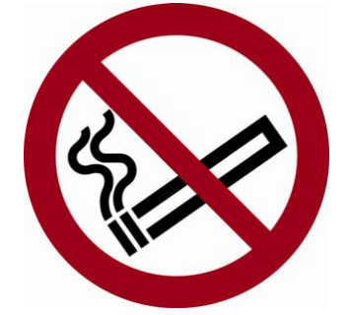
- Observe the fire safety regulations on display.
- Smoking is only allowed on designated smoking islands.
- Heating systems must be kept free of combustible materials at all times.
- Switch off all unneeded devices at the end of work.
- If a fire breaks out or becomes aware of it, notify all employees at risk immediately and call the fire brigade: tel. 112. Answer the fire brigade's questions briefly and objectively. If possible, fight small fires starting with existing fire extinguishers. Pay attention to intrinsic safety and do not breathe in harmful fire gases.
- • Fire extinguishers must be operated as follows:
- - Remove the extinguisher from the holder and carry it to the source of the fire
- - Place on the ground at a safe distance from the scene of fire.
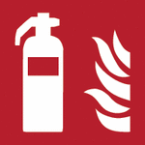
- - Remove the locking element (splint or plastic element).
- - keep the spray hose in the direction of the fire, and
- - Activate the pressure lever or knob and hold the spray jet on the fire

Lfd. Nr. | Name, Vorname | Unterschrift
1
2
3
4

